SMART PARKING

PHASE_2:CAMERA BASED PARKING DETECTION

**Camera based parking detection** in IOT refers to using cameras and internet of things (IOT) technology to monitor and analyse parking spaces in real time. This system uses cameras to capture images or videos of parking areas, and then utilizes computer vision algorithms and machine learning techniques to analyse these visuals and detect the presence or absence of vehicles in the parking spaces.

**Parking enforcement:** By detecting the presence or absence of vehicles in parking spaces, this system can be used to enforce parking regulations and prevent unauthorized parking. It can alert authorities when a vehicle is parked in a restricted area or exceeds a time limit 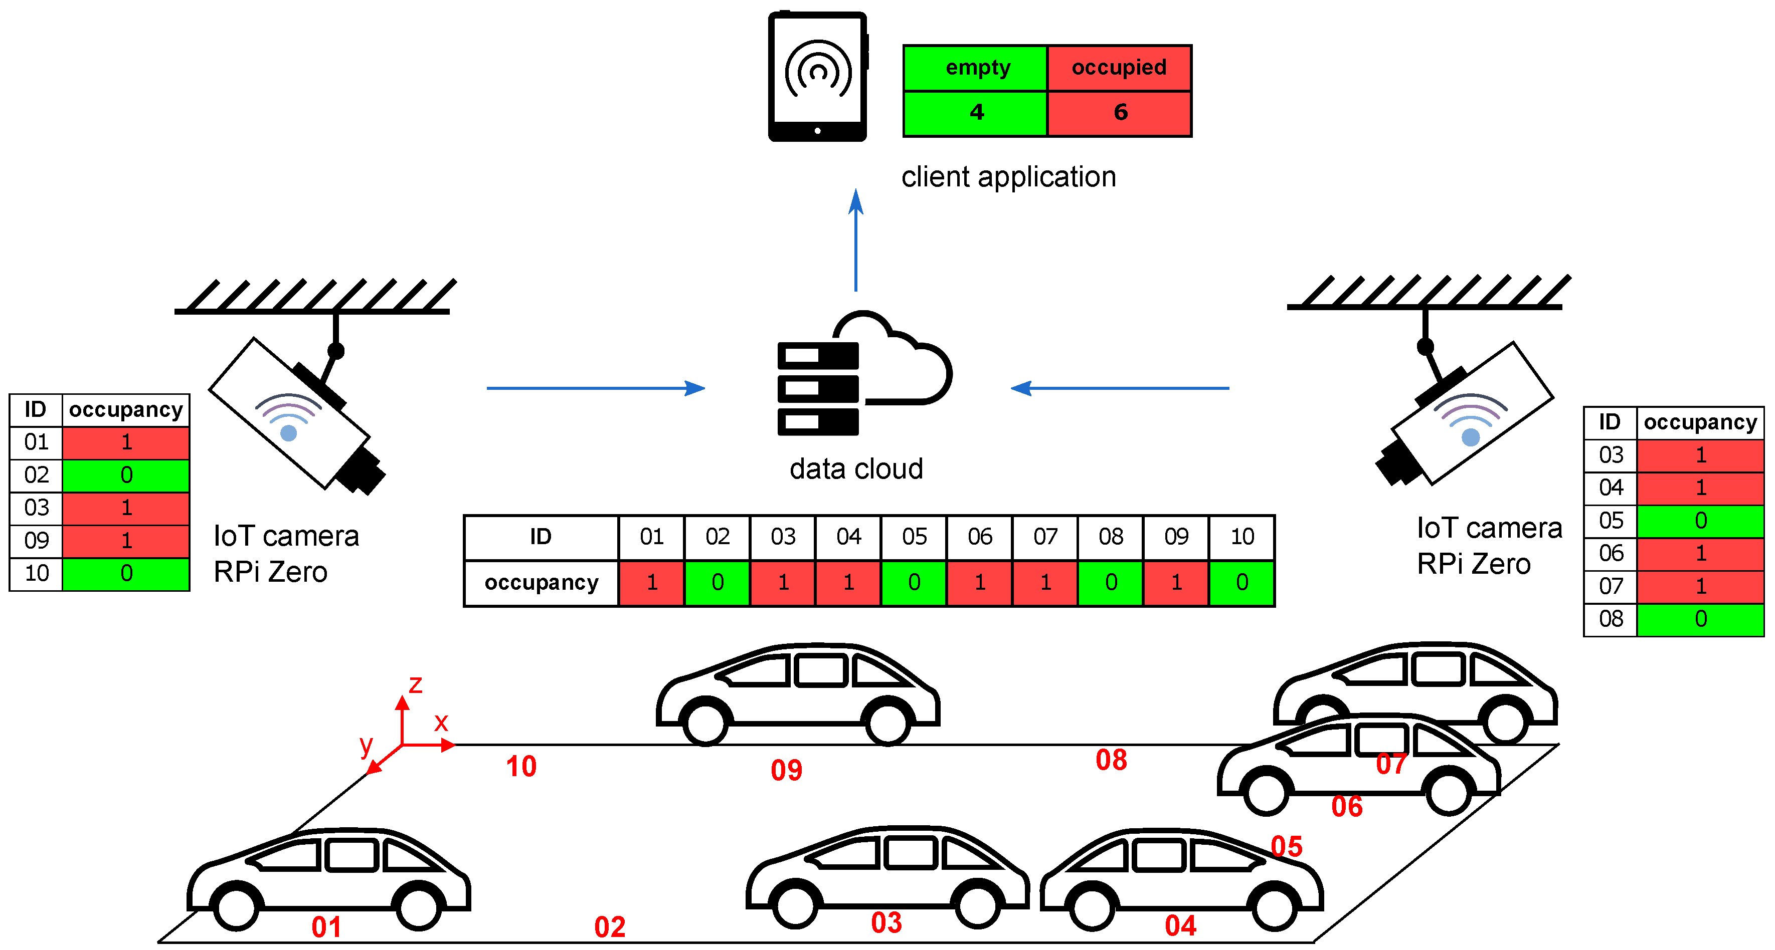

**1. Camera Monitoring:** Cameras installed in parking areas continuously capture images or videos of the parking spaces. The cameras may be fixed in position or have the ability to pan, tilt, and zoom for a wider coverage area.

**2. Data Transmission:** The captured visuals are transmitted over a network connection, such as Wi-Fi or Ethernet, to a centralized server or cloud platform. This allows for remote access and monitoring of the parking spaces.

**3. Image Processing:** On the centralized server or cloud platform, computer vision algorithms and machine learning models are applied to process the captured visuals. These algorithms analyse the images or videos to detect the presence or absence of vehicles in the parking spaces.

**4. Vehicle Detection:** The computer vision algorithms utilize techniques such as object detection, image classification, or pattern recognition to identify and locate vehicles within the parking areas. These algorithms have been trained on large datasets to accurately identify vehicles in different lighting conditions and angles.

**5. Real-time Monitoring:** As the detection process occurs, the system provides real-time monitoring of the occupancy status of the parking spaces. It can indicate whether a space is vacant or occupied, and update this information continuously.

**6. Alerts and Notifications:** The system can generate alerts and notifications based on specific conditions. For example, it can notify authorities or parking operators when a violation,

**7. Integration with IOT Devices:** The parking detection system can be integrated with other IOT devices or systems, such as smart parking meters or mobile applications. This integration allows for seamless connectivity and automation, enhancing the overall parking experience.

**9. Maintenance and Updates:** Regularly maintain and update the cameras, algorithms, and cloud platform to ensure the system's optimal performance and accuracy. This may involve monitoring the camera hardware, training the machine learning models with new data, and applying software updates.

**10. Security:** Implement proper security measures to protect the data transmitted and stored by the parking detection system. This may involve encryption, access controls, and monitoring for any potential security breaches.

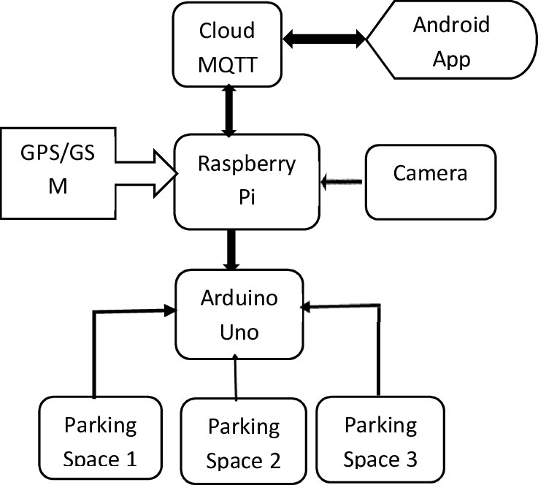

Remember that camera based parking detection in IoT is a complex system that involves multiple technologies and components. It is important to thoroughly plan and test each step to ensure a reliable and accurate parking detection system.

Overall camera based parking detection in IOT offers a smart and efficient solution for managing parking spaces, improving the overall parking experience, and optimizing parking operations in cities and other urban environments.

While programming is required to develop and implement the necessary software components for the camera-based parking detection system, the **Raspberry Pi** provides a flexible and cost-effective platform for running the required algorithms and managing the system. Whether it's capturing visuals, processing data, networking, or integrating with other IoT devices, the Raspberry Pi can effectively perform these tasks in a camera-based parking detection system in IoT.